Assessment of Hot-spots in Structures Using the IR Quasi-Static Method
V.E.L. Paiva, G.L.G. Gonzáles, R.D. Vieira, J.L.F. Freireª, L.C. Mendes
Department of Mechanical Engineering
Pontifical Catholic University of Rio de Janeiro, PUC-Rio
Rua Marquês de São Vicente 225, Gávea, Rio de Janeiro, RJ, Brazil
ªjlfreire@puc-rio.br

Abstract. This paper shows that it is possible to locate hot-spot or critical stress points on the surface of structural components by using an IR quasi-static methodology. To accomplish this, temperature measurements were taken while uniaxial or dented pipeline test specimens were quasi-statically loaded under monotonic conditions.

Introduction
Besides being used extensively in nondestructive evaluation (NDE) to detect flaws in structural components, Infrared Thermography (IRT) has also been applied to assess fatigue limits for structural materials by using uniaxial cyclic stress tests, or quasi-static uniaxial tensile tests [1-3]. The quasi-static method was extended to biaxial stress states actuating on the surface of actual-size pipeline test specimens with geometric anomalies [4]. Results showed that the quasi-static biaxial method satisfactorily predicted the location of the hot spots where fatigue cracks had begun to form in the tested specimens. Strain distributions on the same specimens’ hot spots were determined using digital image correlation (DIC). Determining the surface strain states via DIC and corresponding temperature variations for the surface material points observed during the tests made it possible to ascertain not only the material endurance limit, but also what may be called a characteristic minimum temperature (CMT). Uniaxial tests using dog bone specimens from the same material indicate that the CMT measurements are closely related to the material yield strenght (MYS), which is known to increase monotonicaly with the loading history. The present Abstract calls attention to experimental observations relating the stress-strain-temperature measurements to the onset of yielding at the observed points in the uniaxial and biaxial tests. This investigation aims to use the temperature monitoring of structures under quasi-static increased loading to predict how far from the MYS onset the stress states of the observed points are located. Stress states below or over the MYS will be indicated by continuous temperature measurements: a decreasing temperature while increasing tensile stress indicates that the material point is being stressed below its MYS, whereas an increasing temperature indicates that the material point is being tensile-stressed over its MYS.

Experimental Campaign

Seven uniaxial standard dog bone and six 3 m long pipeline specimens with plane headed caps were fabricated from API 5L Grade B (324 mm external diameter and 6.35 mm thickness) steel pipes. The material’s actual mechanical properties of the dog-bone specimen (CP-7) presented in this Abstract were S_{y} = 406 MPa and 450 MPa (0,5% total strain at its first and fifth uniaxial tests) and S_{u} = 460 MPa, respectively, for the engineering yield and ultimate strengths. The pipe specimens had geometric dent anomalies (15% depth related to the external diameter). All the specimens were painted with a thin layer of opaque black paint to increase emissivity. White dots were painted on the pipe specimens‘ surfaces to allow for application of the DIC technique. During each test, the surface temperature of the test specimens was recorded in real time via an FLIR A655sc micro-bolometer thermo-camera (640x480 uncooled micro-bolometers, 50 Hz acquisition rate, 17 µm spatial resolution, 30 mK sensitivity). The temperature data were acquired and analyzed using the ResearchIR software program from FLIR. Displacements of the uniaxial test specimens were measured with a 25 mm gage length clip-gage. The biaxial pipe test specimens were loaded with pressurized water, and displacement measurements using DIC were taken during the first half (pressure increase) of three initial loading cycles. The pressure was increased gradually (0.2 MPa/s) while the DIC measurements were taken. Vic-Snap Software and the Vic 3-D Stereo System from Correlated Solutions Inc. were used. IR temperature measurements were taken under similar test conditions. Elastic stress distributions were also determined via Finite Element (FE) solutions. In those cases, the experimental dent shapes determined by using DIC were input to the FE software. Subsequent fatigue test cycles were carried out with pressure varying from 0.2 MPa to 6.2 MPa at a rate of 1 Hz [4].

Results

Fig. 1 shows stress-strain-temperature curves determined for one uniaxial dog bone specimen (CP-7). The test sequence encompassed five quasi-static tests, with maximum strains reaching 1% (three cycles), 3% and 5%, with a total strain of 10% after the last test (fifth) cycle. The predicted fatigue limit of specimens CP-1 to CP-6 as reported in [4] averaged 245 MPa while being 258 MPa for the CP-7 specimen. The onset of yielding for the five series of tests are clearly defined in Fig.1, not only by the stress-strain curve, but also by the temperature-strain curve. The thermoelastic effect prevails at low stresses and the mechanical plastic strain-temperature behavior fully prevails after yielding. Fig. 2 depicts the 258 MPa endurance limit and more clearly both strain and temperature versus stress curve knees ocurring at about 450 MPa.

Fig. 3 shows the application of the quasi-static IR method for determining the full alternated biaxial fatigue limit of a single steel pipe specimen (Dent 3), [4]. The time axis is used to correlate the temperature measured with the applied pressure, and then with the stress or strain states acting at the observed point. Stresses highlighted on the graph (pressure x time) in Fig.3 were calculated from an elastic FE analysis that used the DIC determined dent shape or were directly determined from strains achieved from the DIC analysis. They can reasonably represent the quasi-linear behavior of actual stresses up to the onset of yielding (assumed to be equal to 450 MPa, fifth test series as depicted in Fig.2). The initial temperature variation given in Fig.3 was curve fitted to minimize temperature measurement noise. The slope deviation point (2% from linear slope) is related to the full-alternate Mises fatigue strength, which is indicated to be 236 MPa as given in [4]. At the onset of yielding (about 450 MPa), the temperature points (from FE and DIC) are located far from the initial linear thermoelastic behavior, but the temperature curve does not present a pronounced knee as depicted in Fig.2 for the uniaxial test. This behavior is under investigation, although a sharp to smooth knee transition is expected in cases where, unlike uniaxial tests where uniform stress distribution ocurrs, stress variation caused by bending occurs across the specimen thickness. Quasi-static loading is also expected to contribute to the non-adiabatic behavior caused by non-uniform stress states actuating on nearby material points.

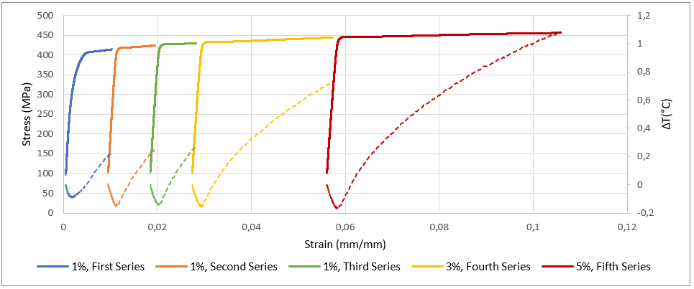
Fig.1: Stress (full lines)-strain-temperature (dashed lines) plots of five quais-static uniaxial tests of one dog-bone specimen, CP-7

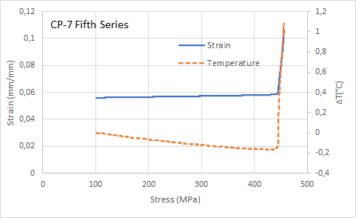 | 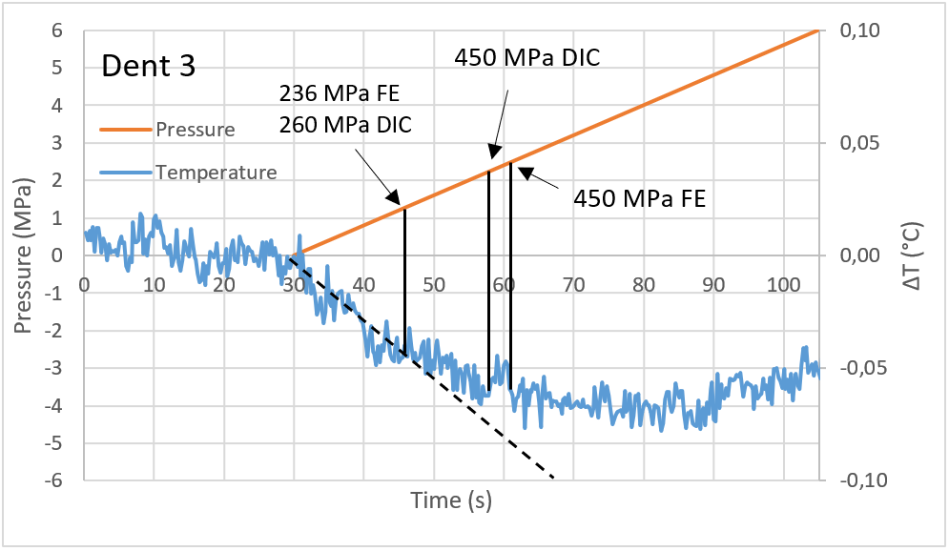
Fig.2: Stress-strain-temperature plot of the fith quasi-static uniaxial test presented in Fig.1 | Fig. 3: Quasi-static IR method applied to a dented steel pipe specimen (Dent 3), also reported in [4]

Acknowledgements. Pipe tests were performed under the project Petrobras-Sigitec 0050-0101-263-16-9 TCBR-409 and conducted at Centro de Tecnologia de Dutos, CTDUT. V.E.L. Paiva and L.C. Mendes were sponsored respectively by Conselho Nacional de Pesquisa e Desenvolvimento, CNPq, and Coordenação de Aperfeiçoamento de Pessoal de Nível Superior, CAPES, during their DSc. and M.Sc. Programs.

References
- La Rosa, G., Risitano, A., (2000) Thermographic methodology for rapid determination of the fatigue limit of materials and mechanical components, International Journal of Fatigue, Vol. 22(1), pp. 65-73.
- Risitano, A., Risitano, G., Clienti, C. (2010) Fatigue limit by thermal analysis of specimen surface in mono axial traction test. EDP Sciences.
- C. Douellou, A. Gravier, X. Balandraud, E. Duc (2021) Heat source reconstruction applied to fatigue characterization under varying stress amplitude, SEM Society for Experiemnatl Mechanics 2021 Annual Meeting on Experimental and Applied Mechanics.
- V.E.L. Paiva, G.L.G. Gonzáles, J.L.C. Diniz, R.D. Vieira, J.L.F. Freire, A.L.F.S. d’Almeida (2020) Infrared Thermography Applied to the Assessment of Fatigue Initiation, Thermomechanics & Infrared Imaging, Inverse Problem Methodologies and Mechanics of Additive & Advanced Manufactured Materials, Volume 7 Proceedings of the 2020 Annual Conference on Experimental and Applied Mechanics.

